Project Title: Travel Ticketing

Team Members:

1. **T. Vardhan.**
2. **M. Bipin Kumar.**
3. **T. Abhinav Singh.**
4. **Use Case diagram**:

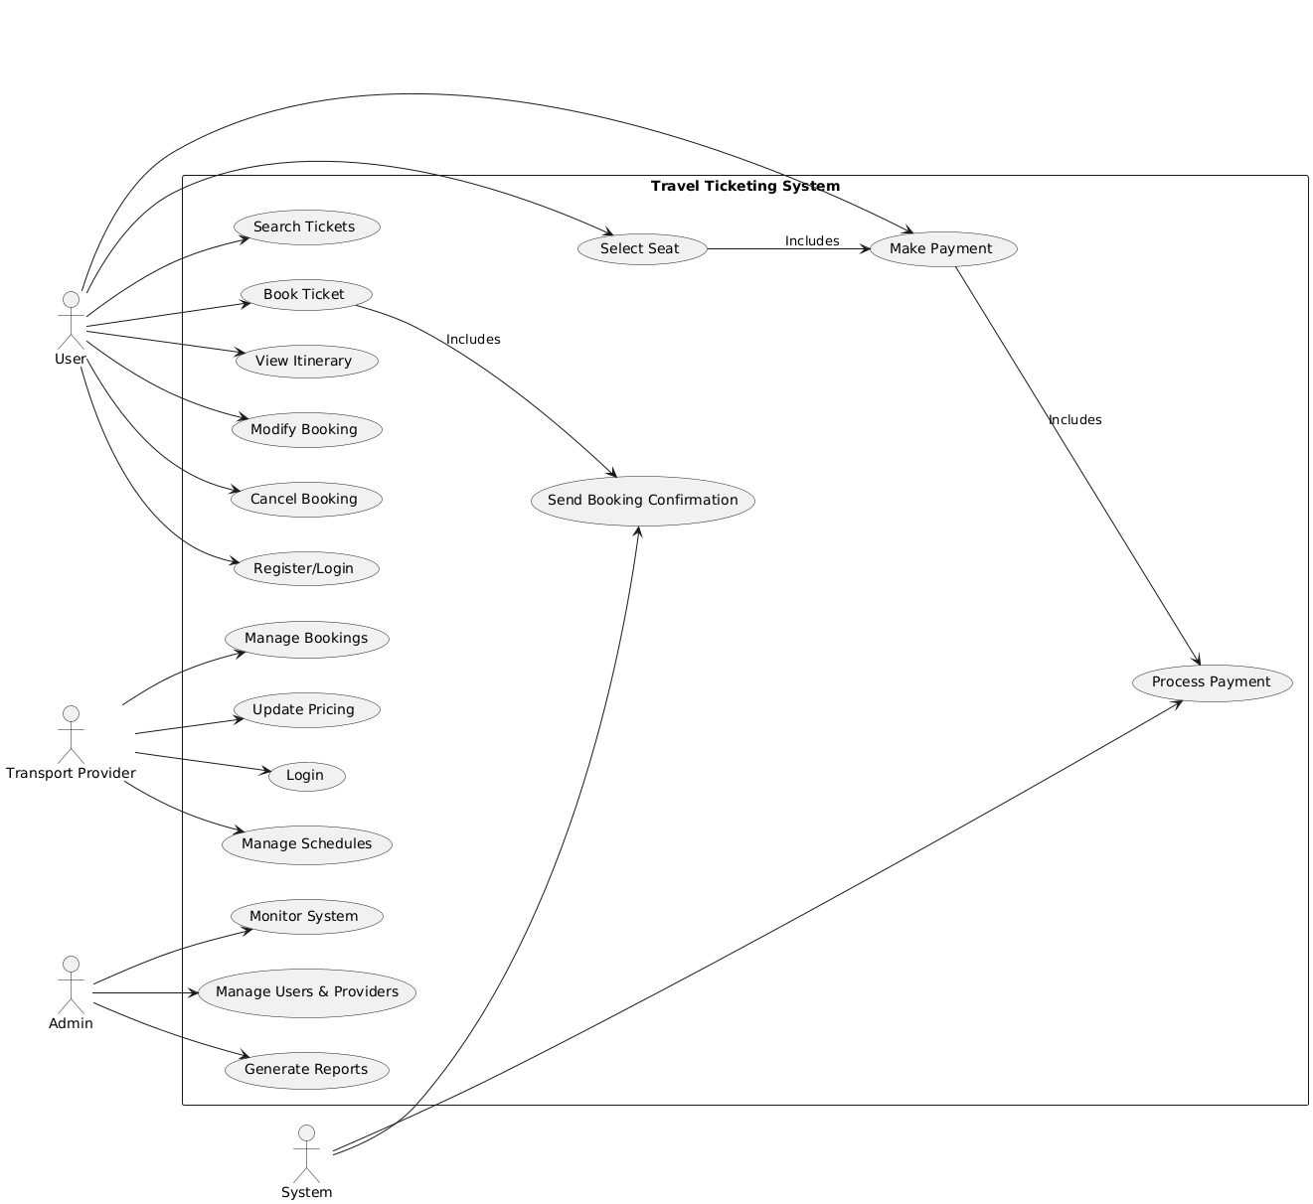

1. **Flow Diagram:**

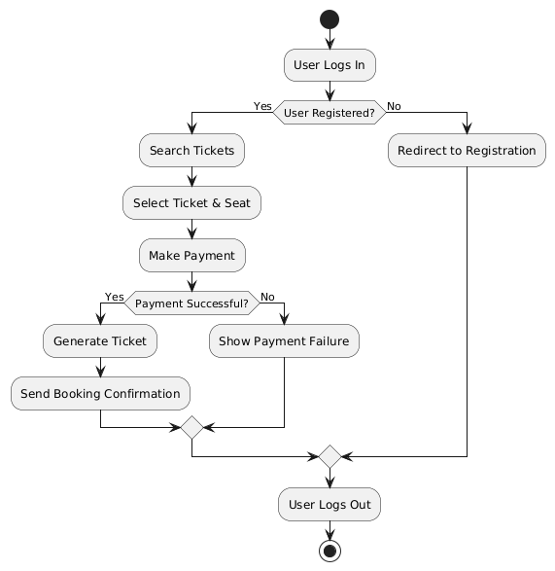

1. **Entity-Relationship(ER) diagram:**

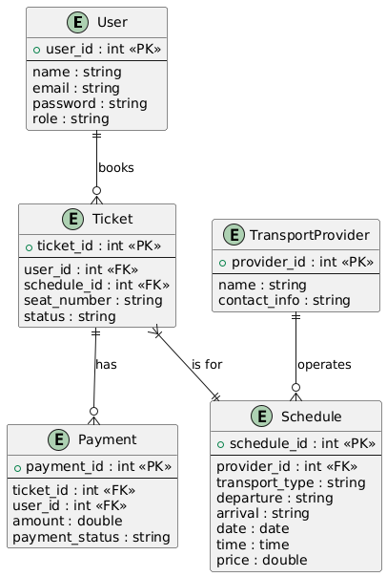

Output Screenshots:

1. **Register Page**

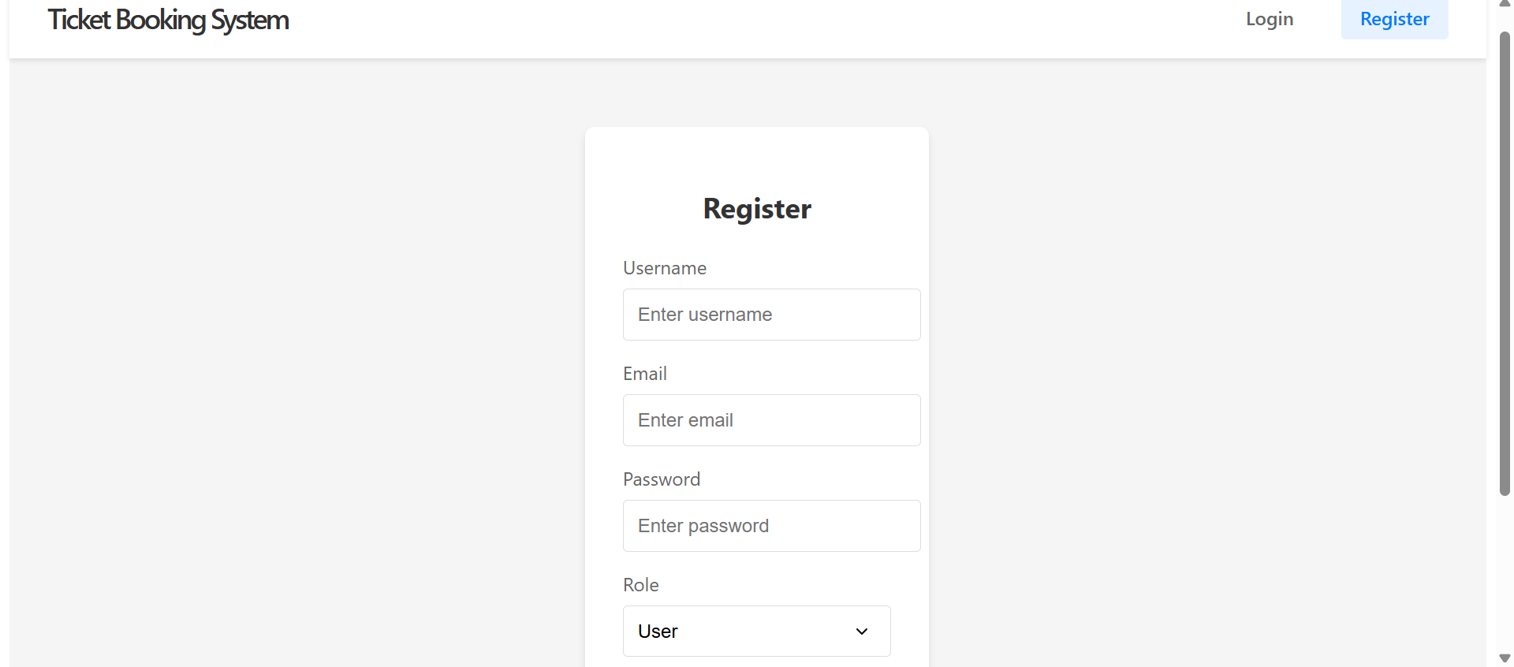

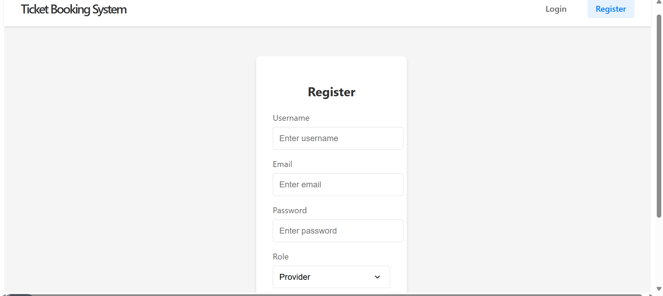

1. **Login Page**

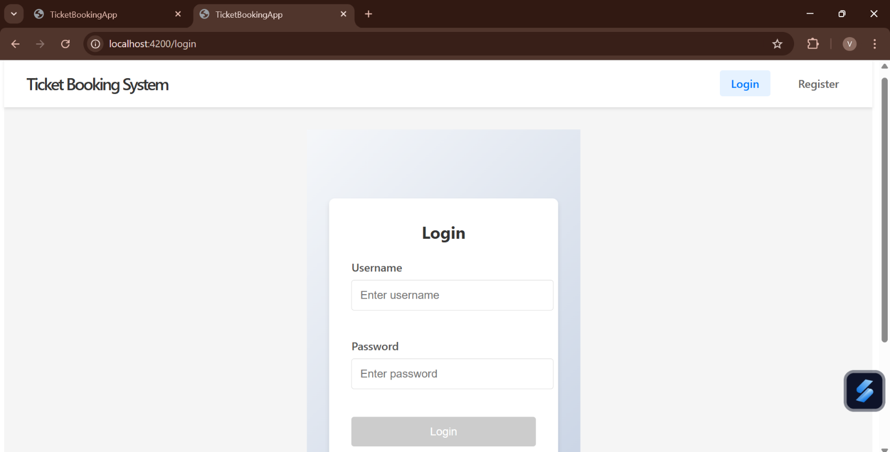

1. **User Search tickets**

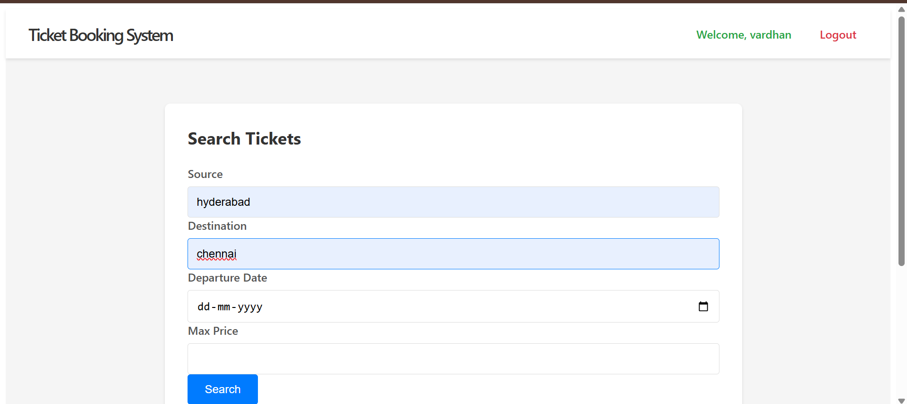

1. **Booked Tickets**

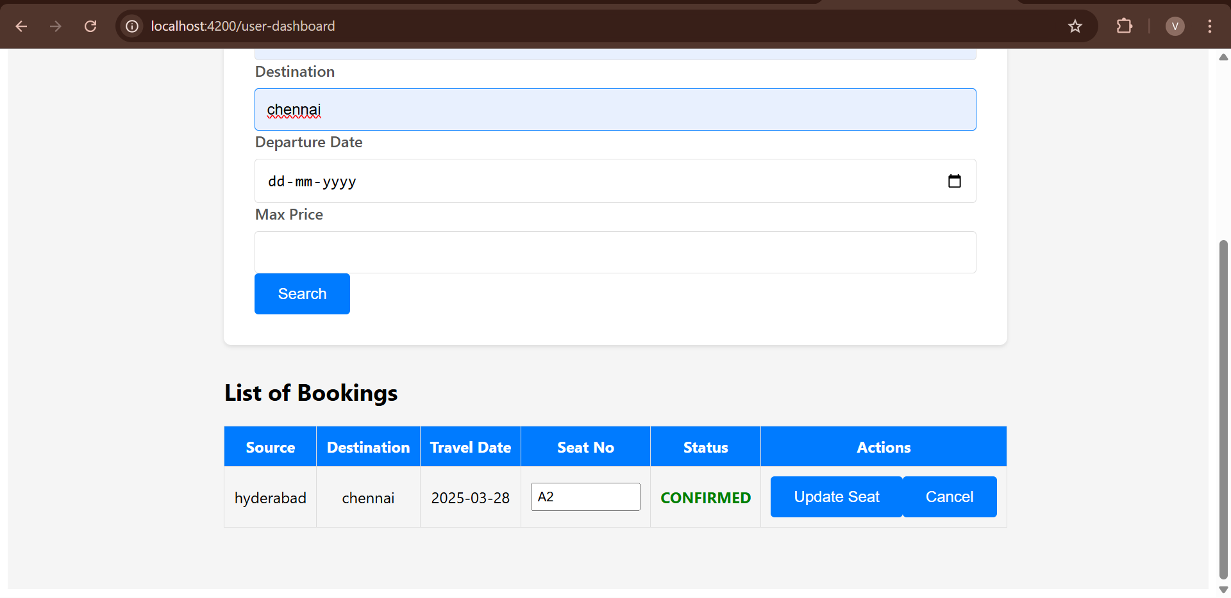

1. **Provider UI**

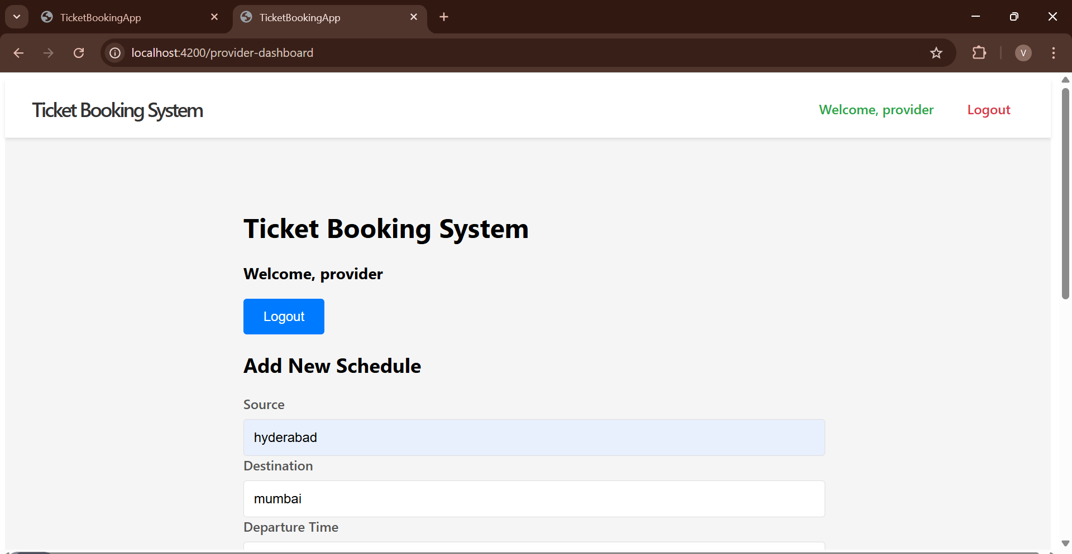

1. **Booked Users**

